

Press Release

07 Aug, 2025

Alltech Vietnam awarded Silver Medal from EcoVadis

[HO CHI MINH CITY, Vietnam] — Alltech Vietnam has been awarded a Silver Medal from EcoVadis, a globally recognized provider of business sustainability assessments. This distinction, which places Alltech Vietnam in the 86th percentile of firms assessed by EcoVadis globally, is a testament to Alltech’s purpose of Working Together for a Planet of Plenty® and the company’s commitment to implementing environmentally and economically sustainable solutions, fostering ethical business conduct, and prioritizing the efficient production of nutritious food.
EcoVadis evaluates companies across 21 sustainability criteria within four core themes: environment, labor and human rights, ethics, and sustainable procurement. Its ratings are based on international sustainability standards, including the Ten Principles of the United Nations Global Compact, the International Labour Organization (ILO) conventions, the Global Reporting Initiative (GRI) standards and the ISO 26000 guidelines.
The Silver Medal from EcoVadis places Alltech’s PDMM Vietnam facility in a select group of companies in Vietnam recognized for outstanding sustainability performance. Only 32 companies across all industries in Vietnam have ever earned a Silver Medal. So far in 2025, only six companies in Vietnam have received one.
PDMM Vietnam is Alltech’s first organic mineral production facility in Vietnam and eighth globally. Commencing operations in Q2 2022, PDMM Vietnam is a state-of-the-art, well-equipped plant dedicated to producing safe and high-quality animal feed supplements.
The PDMM team continuously strives to uphold a systematic and consistent way of working – to ensure that they can provide technologies that consistently meet regulatory requirements and ensure customer satisfaction.
At the PDMM Vietnam facility, key initiatives driving this achievement include greener production using a CNG combustion burner for product drying; heat recovery upgrade with an auto-flame burner; an air compressor/chiller system; and a rooftop solar installation. These initiatives save a significant amount of carbon emissions each year.
“Asia plays a vital role in Alltech’s global purpose of Working Together for a Planet of Plenty®. Our continued investment in the region — from advanced nutritional technologies to sustainable production practices — reflects our deep commitment to supporting our customers, strengthening local economies, and advancing the future of sustainable agriculture,” said Dr. Mark Lyons, president and CEO of Alltech. “Achievements like the EcoVadis Silver Medal are not only a recognition of the hard work of our team in Vietnam, but also a reflection of Alltech’s unwavering belief that business can be a force for good — for people, animals and the planet.”
“This Silver Medal from EcoVadis is a powerful validation of Alltech Vietnam’s efforts and our global ESG ambition,” said Tara McCarthy, Alltech’s global vice president of ESG. “Sustainability at Alltech is not a slogan — it’s embedded in how we operate every day. The PDMM team’s dedication to reducing carbon emissions, improving efficiency, and innovating with purpose is driving measurable progress.”
For more information about Alltech’s sustainability commitments, visit alltech.com/sustainability.
-Ends-

Photo download: https://creative.alltech.com/asset/4e6d37c3-ed1f-45d1-9042-dcc23b7c17af/Web-JPG/PPDM-Vietnam-facility.jpg
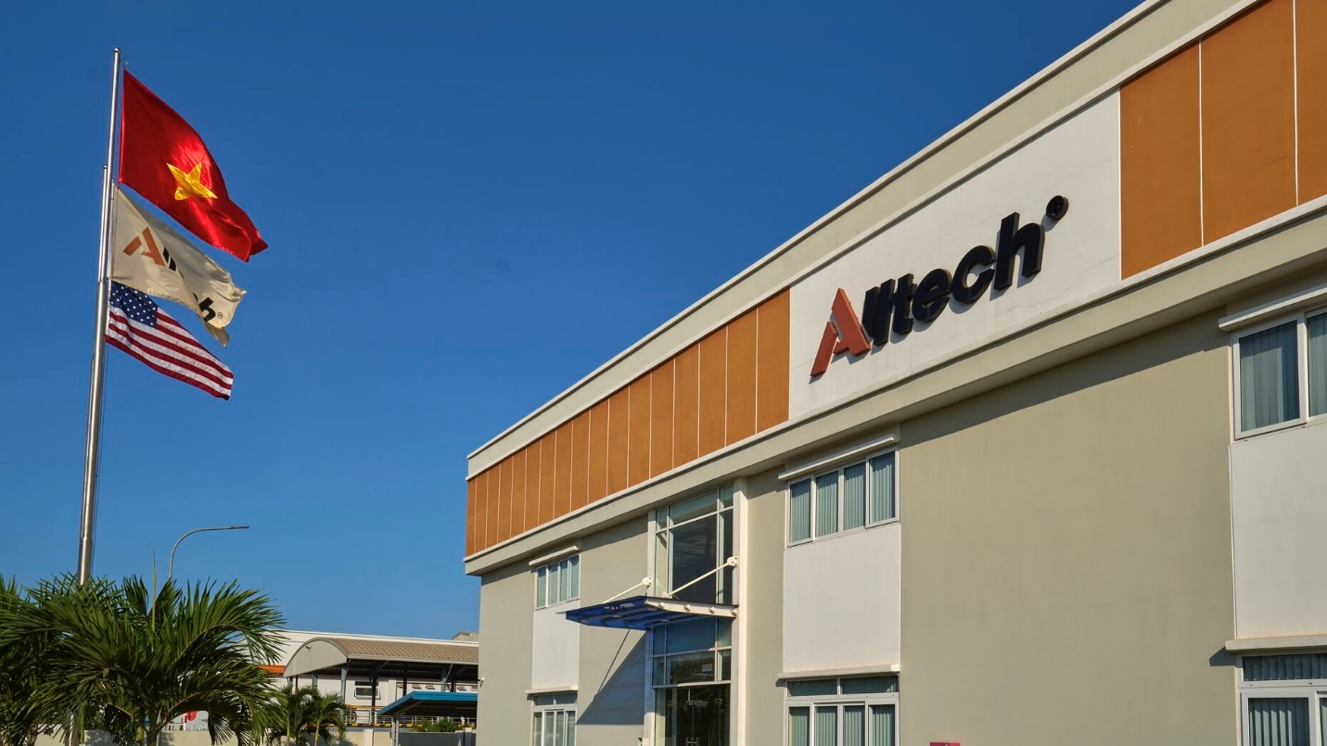
Caption: Alltech Vietnam has been awarded a Silver Medal from EcoVadis, a globally recognized provider of business sustainability assessments. The medal places Alltech Vietnam in the 86th percentile globally.

Contact: Linh Nguyen
Marketing Manager, Vietnam & Cambodia
linh.nguyen@alltech.com; 0084 966714542

About Alltech:
Founded in 1980 by Irish entrepreneur and scientist Dr. Pearse Lyons, Alltech delivers smarter, more sustainable solutions for agriculture. Our diverse portfolio of products and services improves the health and performance of animals and plants, resulting in better nutrition for all and a decreased environmental impact.
We are a global leader in the agriculture industry. Our team produces specialty ingredients, premixes, supplements, feed and biologicals, backed by science and an unparalleled platform of services.
Strengthened by more than 40 years of scientific research, we carry forward a legacy of innovation and a unique culture that views challenges through an entrepreneurial lens. As a private, family-owned company, we adapt quickly to our customers’ needs and focus on advanced innovation.
We believe agriculture has the greatest potential to shape the future of our planet. Our more than 5,000 talented team members worldwide share our purpose of Working Together for a Planet of Plenty®. Together, we can provide nutrition for all, revitalize local economies and replenish the planet’s natural resources.
Headquartered just outside of Lexington, Kentucky, USA, Alltech serves customers in more than 140 countries, has five bioscience centers, and operates more than 75 manufacturing facilities across the globe.
For more information, visit alltech.com, or join the conversation on Facebook, X and LinkedIn.

